Mental Well-Being

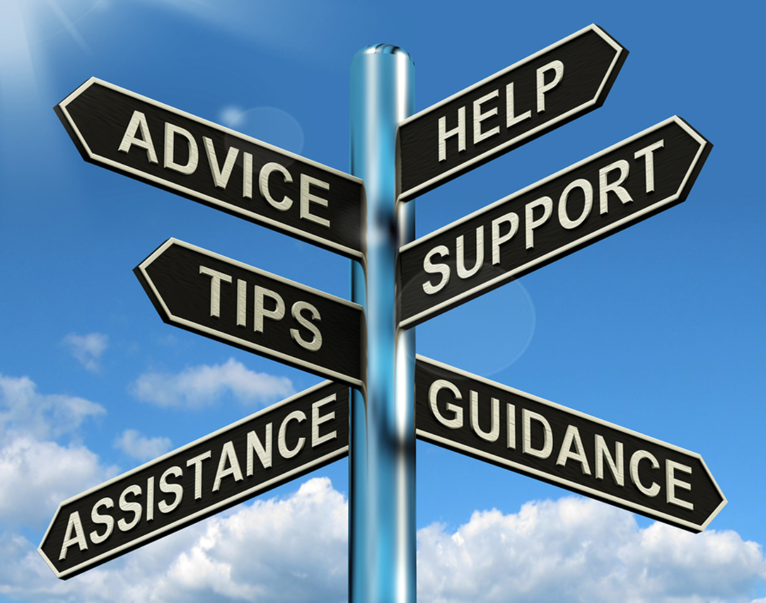



- Resources Specific to the Legal Industry
- Regional Resources
- National Resources
- Mental Health Resources for Queer, Trans, Black, Indigenous, People of Color Communities



Post-COVID syndrome: Mental health
https://www.youtube.com/watch?v=Rn306wjvl3g&ab_channel=Osmosis

Mental Health Awareness & De-Escalation
https://www.youtube.com/watch?v=FoZ-3l6hMGQ&ab_channel=AllCEUsCounselingEducation

Six Habits That Break Your Mental Health
https://www.youtube.com/watch?v=BqtweDhvG50&ab_channel=Psych2Go

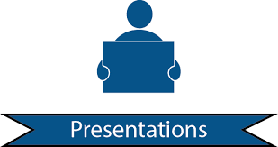
ALA Annual Conference 2021

“Wellness and the Legal Community: Conversations and Tips on Burnout and Stress”
Lynn Garson, Counsel, Baker Hostetler
(Link to PP Presentation)

“Default or Defined: What We Can Do to Positively Influence Culture in our Firms”
Judy Hissong, President, Nesso Strategies
Monique Mahler, HR Manager, Baker Hostetler
(Link to PP Presentation)

“A Workplace Built for 2021 and the Future: Examining DEIB and Mitigating Implicit Bias”
Michael Cohen, Duane Morris LLP
(Link to PP Presentation)

