Monthly Diversity Observances

January | Dr. Martin Luther King, Jr. Day – National Day of Service  January 18, 2021  https://www.dodea.edu/dodeaCelebrates/MLK.cfm | 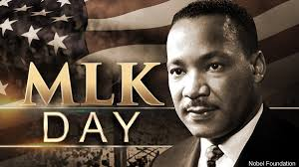
February | Black History Month  https://www.history.com/topics/black-history/black-history-month | 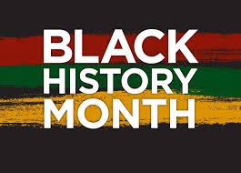
March | Women’s History Month  https://womenshistorymonth.gov/ | 
April | Autism Awareness Month  https://www.autism-society.org/get-involved/national-autism-awareness-month/ | 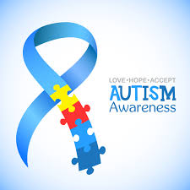
April | Passover – March 27 – April 4, 2021  https://www.myjewishlearning.com/article/passover-2021/ | 
April | Easter – April 4, 2021  https://www.history.com/topics/holidays/history-of-easter | 
April | Ramadan – April 12 – May 15, 2021  https://www.shrm.org/resourcesandtools/hr-topics/behavioral-competencies/global-and-cultural-effectiveness/pages/accommodating-muslim-employees-during-ramadan.aspx | 
May | Asian Pacific Heritage Month  https://asianpacificheritage.gov/ | 
May | Mental Health Awareness Month  https://www.nami.org/Get-Involved/Awareness-Events/Mental-Health-Month | 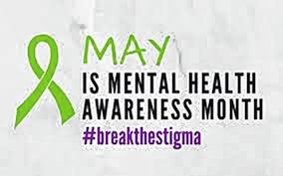
June | LGBTQ Pride Month  https://abcnews.go.com/US/lgbt-pride-month-2020-history-events-parades/story?id=71017699 | 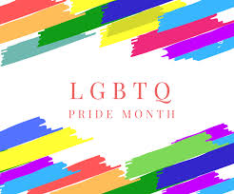
June | Juneteenth – June 19, 2021  https://www.juneteenth.com/history.htm | 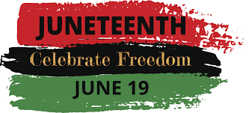
July | Independence Day  https://www.history.com/topics/holidays/july-4th | 
September | Hispanic Heritage Month  https://hispanicheritagemonth.gov/ | 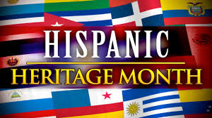
October | National Disability Employment Awareness Month  https://www.whatcanyoudocampaign.org/psa-campaigns/ | 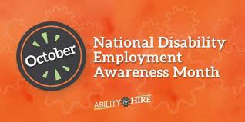
November | National Native American Month  https://www.whitehouse.gov/presidential-actions/presidential-proclamation-national-native-american-heritage-month-2019/ | 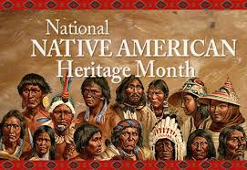
December | Religious Celebrations:  Kwanzaa – December 26, 2020 – January 1, 2021  https://www.history.com/topics/holidays/kwanzaa-history | 
December | Christmas – December 25th  https://www.history.com/topics/christmas/history-of-christmas | 
December | Hanukah – December 10 -18, 2020  https://www.history.com/topics/holidays/hanukkah | 

